Teacher Professional Learning and Effectiveness System
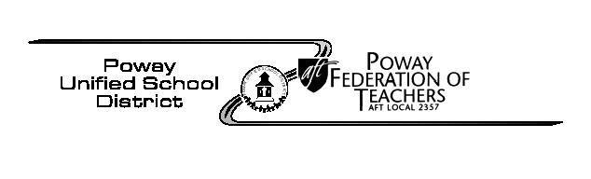  REMINDERS | February, 2019

For those being evaluated this year using the Traditional format, you are right in the middle of the second round of observations. For both Traditional and Alternative formats, your administrator will soon be asking to schedule your final evaluation conference. With that in mind, we wanted to remind you that now is the perfect time to be updating Part Two of your Student and Professional Learning Objective (SLO/PLO). In addition, your administrator will probably ask you to have your final reflection (Part Three) done before the final conference.

REMINDER: Part Two looks like this:
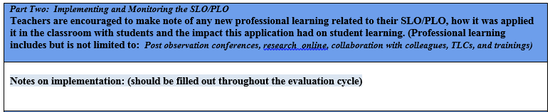
REMINDER: Here are some examples of things to document. You don’t have to write an essay; bullet points are fine to remind you of what you want to talk about in your conference with your administrator.
- 10/20/17  Post observation with ____ | - Tried pair share suggestion | - Noticed increase in participation in whole group discussion overall (see participation data sheet)
- 2/1/18  Peer observation with ____ | - He provided feedback on DOK-prewrote questions in advance | - Questions at all levels used. Next will try writing student initials beside questions to differentiate?
- 3/15/18  Video observation feedback | - My peer suggested group role and responsibility training for group tasks; shared resources; Implemented group roles; practiced on math task | - Student participation and on task behavior was much higher; rotation of roles allowed all students to experience different leadership tasks=equity
- Team/Department meeting- 1 per trimester | - Common assessment administered to students; did pass around grading with rubric for calibration | - Grade level expectations clear; agreed on teaching points for next trimester to improve overall scores
Other examples of “Action Research”: Online: Teaching Channel Video, Online Edutopia, Educational Leadership Journal,
TLC: Growth Mindset, Master’s class: Data use for equity, Benchmark PL session, Presentation from RtI TOSA, Observed colleague in department, NGSS activity at staff meeting, SDCOE presentation on technology, XPloration Collaboration Day

REMINDER: Part Three looks like this:
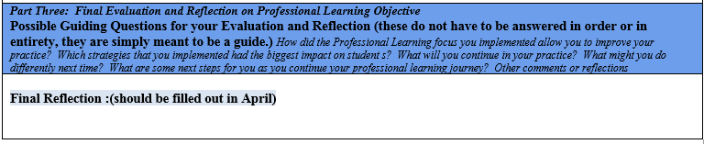
Use your final reflection as an opportunity to highlight specific areas that you focused on and new strategies you tried in this year. Use it as an opportunity to explain or share things that may not have been observed during a classroom observation.

REMINDER: TPLES TLC participants:
The final assignment to earn your TLC points requires submission of parts 2 and 3 of your SLO/PLO by April 30. Remember when you submitted a link to your SLO/PLO as a Google doc to the discussion board in October? If you’re updating the same document, you won’t have to submit anything new. The link to your Google doc will include all updates!
If you are unsure that the link you submitted is correct, check your discussion board post.

For questions or additional support, contact:
Susan Joyner
sjoyner@powayusd.com

